Concept of Operations

Project Grover: The Geoglyph Rover

Friday, 9 August 2024

|  |
| --- |
| TEAM ROOK |
| Abhishek Chozhiyattil | U7616838 |
| Adnan Azmie | U7601545 |
| Russell Rehim | U7615646 |
| Vikalp Shendekar | U7517877 |
| Viswadeep Kopalli | U7405095 |

# Version Control

|  |  |  |
| --- | --- | --- |
| **Version** | **Date** | **Notes** |
| V 0.0 | 02/08/2024 | Original |
| V 0.1 | 05/08/2024 | Timeline, Boundaries |
| V 0.2 | 05/08/2024 | Goals & Objectives, Scope Management |
| V 0.3 | 05/08/2024 | Referenced Doc, Team Structure, Responsibilities |
| V 0.4 | 09/08/2024 | Stake Management Plan & Risk Analysis |
| V 1.0 | 09/08/2024 | Signature and Agreements |
| V 1.1 | 09/08/2024 | Document Overhaul and Restructuring |

# Preface

This Concept of Operations (ConOps) document provides a comprehensive overview of Project Grover, an initiative to develop a large-scale outdoor drawing robot. It is intended as a guide for all stake holders.

This document’s purpose is to outline the system’s objectives, operational context, and key functionalities to provide a clear and shared understanding of the system’s purpose and scope. This document serves as a roadmap between the initial concept and detailed system requirements to ensure a unified vision on the project’s goals and outcome among all the stakeholders

This document will evolve and change throughout the course of the project, as additional requirements and insights are identified. This allows the Team and the involved stakeholders to be aligned throughout the project lifecycle and to ensure consistency in system development and to maintain the initial intent of the project.

Operational needs and expectations of the project are defined in this document to support decision making processes, facilitate effective communication, and contribute to successful implementation and deployment of the project.

Team Rook is committed to deliver a working robot that achieves all the requirements of the project and meets the client expectations while holding high standards of quality, performance and user satisfaction. ConOps is a crucial component in achieving that commitment.

Contents

Version Control I

Preface II

List of Tables 2

Project Timeline 3

1 Scope 4

1.1 Identification 4

1.2 Document Overview 4

1.3 System Overview 4

2 current system 5

2.1 background, objectives, and scope 5

2.1.1 Objectives and Goals 5

2.1.2 Strategy 6

2.1.3 Proposed method to the client 6

2.2 Operational policies and constraints 7

2.2.1 Strategy For Operational Constraints 7

3 Scope Management Plan 7

3.1 Control Measures 7

3.2 Utilization of Resources 7

3.3 Change Control Process 7

3.4 Additional Measures 8

4 Referenced Documents 8

4.1 Project Management Plan 8

4.1.1 Function Flow Block Diagram (FFBD) 8

4.1.2 Timelines Table: 8

4.1.3 Risk Assessments 8

4.1.4 Other documents 10

5 Team Structure 10

5.1 Team A (Data Acquisition) 10

5.1.1 Members 10

5.2 Team B (Design & Manufacturing) 11

5.2.1 Members 11

6 Responsibilities and Authorities 11

6.1 Stakeholder Management Plan 12

6.1.1 Identification of Stakeholders 12

6.1.2 Communication Plan 12

6.1.3 Engagement Strategies 12

6.1.4 Feedback and Adaptation 12

6.1.5 Documentation and Reporting 12

6.1.6 Risk Management 12

SIGNATURES AND AGREEMENTS 13

# List of Tables

Table 1 Technical Risks 6

Table 2 Project Management Risks 7

Table 3 Stakeholder Risks 7

Table 4 Environmental and Operational Risks 7

Table 5 Financial Risks 8

Table 6 Stakeholder mapping 9

# Project Timeline

|  |  |  |
| --- | --- | --- |
| **Milestone** | **Date** | **Description** |
| Project Kick-off | 26/07/2024 | Initial team meeting and project planning |
| Design Completion | 09/08/2024 | Finalize system design |
| Integration Phase |  | Integrate hardware and software components |
| Testing Phase |  | Conduct system testing and validation |
| Final Deployment |  | Full system deployment and demonstration |
| Project Completion |  | Submit final report and deliverables |

# Scope

## Identification

Project Grover is an ambitious initiative aimed at developing a large-scale outdoor drawing robot capable of autonomously executing specified tasks. Leveraging advanced technologies such as GPS, Lidar, Sonar, 3D cameras, and long-range radio systems, the project builds on foundational work from Tech-Launcher and utilizes open-source software to create a robust mechanical drawing system.

Initially integrated with a RC vehicle for simulation purposes, the project will transition these autonomous capabilities to a commercial line marking machine. Key aspects include conducting autonomous simulations, utilizing advanced technologies to enhance performance, collaborating closely with the Project Host (ANU College of Arts) to meet specific drawing requirements, and performing thorough testing and validation in designated ANU Ovals. Comprehensive documentation of progress, challenges, and outcomes will be maintained, with final deliverables presented to stakeholders. Ultimately, Project Grover aims to deliver a fully autonomous line drawing machine capable of performing specific tasks with high precision, demonstrating the practical application of advanced robotic technologies.

This document applies to the overall system and describes the various systems involved in the project and their implementation. It is used to communicate, document and justify changes done during the project lifecycle. This document will also serve as a guide to the systems engineering aspects of the project.

## Document Overview

The purpose and motivation of this ConOps document is to communicate the team’s understanding of the client’s needs and how the team shall operate to fulfil their needs.

## System Overview

This ConOps applies to the entire project i.e., converting a line drawing machine to operate autonomously so that it can perform specific drawing tasks in a football oval. To achieve this goal, the team will be using the systems engineering model shown in the picture below.

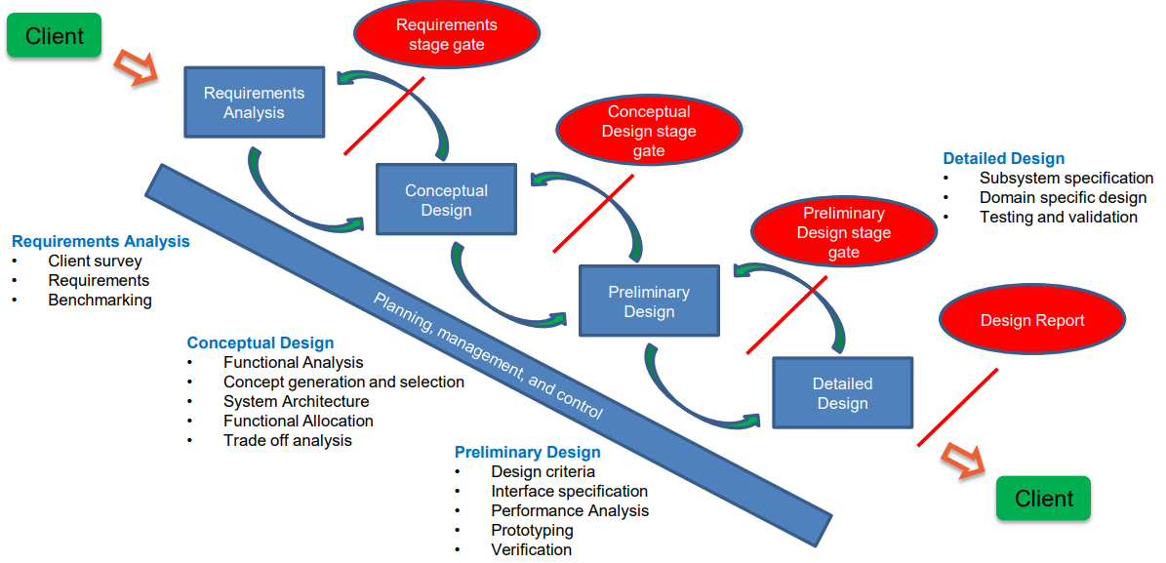

Figure 1 Systems Engineering Design Process.

RC Vehicle as a Prototype

* Using the RC vehicle to kickstart the project and perform autonomous simulation.
* Ensuring the RC vehicle accurately simulates the final autonomous behaviour of the line drawing machine.

Integration to Line Drawing Machine

* Transitioning the tested and validated autonomous capabilities from the RC vehicle to the actual line drawing machine.
* Ensuring the line drawing machine can autonomously execute specified drawing tasks.

Autonomous Operation in Specified Locations

* Final goal is for the line drawing machine to autonomously perform specific drawing tasks in any of the ANU Ovals provided by the project team.

Ongoing Collaboration and Testing

* Client Interaction: Continue collaboration with clients to refine drawing requirements and ensure the final product meets expectations.
* Comprehensive Testing: Perform rigorous testing and validation of the autonomous line drawing machine in various outdoor settings. Testing each subsystem after implementation to ensure precise operation or propose a change to solve problems encountered during each stage.

Comprehensive Documentation

* Project Reports: Detailed documentation of each phase, including development, integration, testing, and client feedback.
* Final Presentation: Presentation of the overall project outcomes, highlighting the transition from RC vehicle simulation to a fully autonomous line drawing machine.

# current system

## background, objectives, and scope

The motivation behind developing a geoglyph drawing robot is to draw large scale drawings outdoors. Since the size of the art is huge, a human centric approach would be time consuming and expensive. To solve this problem, a robot that can draw large scale art utilising GPS coordinates was proposed. Our work builds on foundations laid by the team preceding us and the foundations laid by them start on a RC vehicle. The vehicle has been fitted with a Cube Orange Plus (flight computer), which runs on the Ardupilot software. The team that handled the RC vehicle development ran the RC vehicle using the flight computer and documented successful runs. However, the team was not able to improve the accuracy of the GPS and thereby the RC vehicle was unsuitable for drawing applications. Apart from the RC vehicle team there is a software team that developed the Grover Planner software, which, takes images in svg format and gives GPS mission points that the robot needs to follow to draw a geoglyph. The software team is currently working on improving the accuracy of the GPS and implementing computer vision in the final robot.

### Objectives and Goals

* Use the cubeOrange plus to maintain compatibility with the grover planner software.
* Use a scale model to implement autonomous algorithms to ensure the robot follows the intended GPS waypoints.
* Use the scale model as a testbed to implement and develop software for autonomous capabilities, computer vision and implementation of probabilistic filters.
* Develop a cost-effective drive train for the line drawing machine to integrate it with the autonomous sub-system of the robot.
* Develop the necessary math and control systems to ensure precise control of the robot.
* Increase the localisation accuracy of the robot and the GPS.
* Test and propose changes to software developed by the software team.
* Implement Robot Operating System on the scale model to leverage its built-in packages for autonomous robotics.
* Autonomously follow GPS waypoints on a football oval to draw a geoglyph.

### Strategy

* Use the design engineering process shown in Figure 1.
* Reiterate the design process and verify if the proposed design works.
* Approach the project in a subsystems point of view, to ensure that each proposed design works before progressing forward.
* Testing of every subsystem before proceeding forward with the project.
* Divide the Team into 2 teams to focus on the drivetrain sub-system and autonomous sub-system
* Both teams monitor and review each other’s work to foster an environment where ideas are shared freely. This also allows both the teams to make necessary changes as both subsystems evolve over the lifecycle of the project.
* Tasks are scheduled weekly allowing us to monitor the design and development process closely.

### Proposed method to the client

* Implement Robot Operating System (ROS) and integrate with the existing hardware.
* Use a Raspberry pi as a ground station to control the robot.
* Integrate ROS with the existing hardware.
* Derive the dynamics of the line marking machine to simulate and size the required hardware.
* Develop a CAD model for the line drawing machine.
* Use probabilistic filters to improve the localization accuracy of the robot.
* Test the Grover Plotter software and give feedback to the software team.
* Two modes of operation for the robot, autonomous and human control.
* Test and implement long range radio to communicate with the robot.
* Use jetson nano as the onboard computer on the robot.

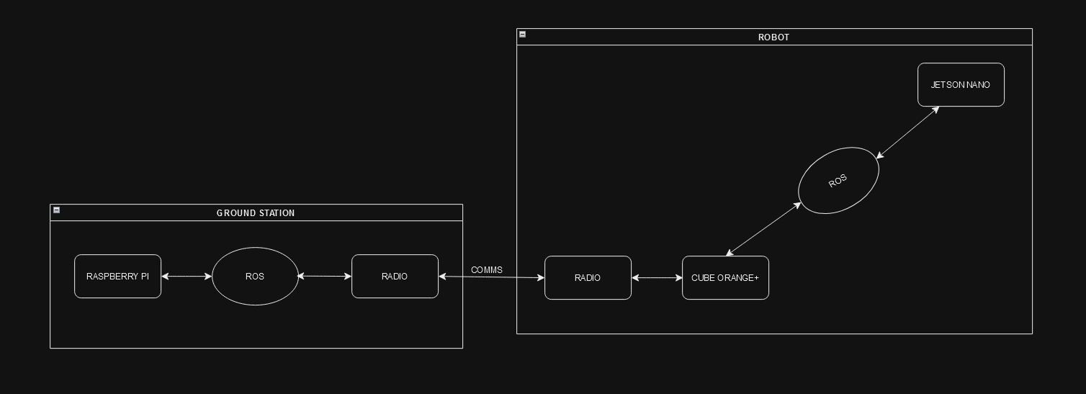

Figure 2 Top-level system architecture of the proposed method.

## Operational policies and constraints

* Mission planner software and cubeOrange plus must be used.
* Funding constraint, client is price sensitive.
* Must work with Grover Planner software.
* Must operate on low power computers, (Raspberry pi, Jetson Nano, etc.)

### Strategy For Operational Constraints

* Show proof of concept for the proposed design.
* Design low cost but effective solutions over multiple design iterations.
* Integrate ROS with the ardupilot software using existing packages
* Test the Grover Planner software for bugs and provide feedback to the client and the software team.
* Develop algorithms to run on resource scare hardware.

# Scope Management Plan

To ensure the project's scope is maintained and managed effectively, the following control measures and processes will be implemented:

## Control Measures

* Regular Project Meetings: Conduct regular meetings with stakeholders through Microsoft Teams and in-person at ANU College of Arts to review progress and discuss any potential scope changes.
* Detailed Documentation: Maintain comprehensive documentation of project requirements and specifications to serve as a reference for scope verification.
* Change Control Process: Implement a structured change control process to evaluate and approve any proposed changes to the project scope.

## Utilization of Resources

* Workshop and Storage: Allocate specified workshop and storage space at Birch Building for working on the RC vehicle and line drawing machine.
* Engineering Building: Use the Engineering Building for working on SolidWorks to develop CAD models for the line drawing machine.
* GitHub Repository: Employ GitHub for project repository management and document storage.
* Team Meetings: Arrange in-person project member meetings at Toad Hall, ANU, for discussions without the host group.

## Change Control Process

* Identification: Any team member or stakeholder can propose a change to the project scope.
* Evaluation: The proposed change is reviewed by the project team and stakeholders to assess its impact on the project's goals, timeline, and resources.
* Approval: If the change is deemed beneficial and feasible, it is approved by the project manager and relevant stakeholders.
* Implementation: The approved change is integrated into the project plan, with necessary adjustments made to the timeline and resources.
* Documentation: All changes are documented and communicated to all team members and stakeholders to ensure transparency and alignment.

## Additional Measures

* Collaborative Tools: Utilize Microsoft Teams for virtual collaboration and communication, ensuring efficient coordination among team members.
* In-Person Collaboration: Facilitate hands-on work and collaboration at designated locations, such as Birch Building and Toad Hall, to enhance productivity and project cohesion.
* Continuous Learning and Improvement: Use the project as a learning platform to refine automation techniques and iterate on improvements to the line drawing equipment's operational efficiency.

By adhering to this enhanced scope management plan, the Capstone team will maintain a clear and focused project trajectory, ensuring that Project Grover achieves its intended outcomes efficiently and effectively. The integration of structured control measures, robust change management, and strategic utilization of resources will support the team's efforts in automating the line drawing machine and achieving project success.

# Referenced Documents

## Project Management Plan

### Function Flow Block Diagram (FFBD)

### Timelines Table:

|  |  |  |
| --- | --- | --- |
| Milestone | Deadline | Deliverable |
| Project Kick-off | 29/07/2024 | Initial meeting and scope definition |
| Design Phase | 08/08/2024 | Completed CAD models |
| Simulation Completion |  | RC vehicle autonomous simulation |
| Integration Phase |  | Line drawing machine integration |
| Testing Phase |  | Outdoor testing in ANU Ovals |
| Final Presentation |  | Project outcomes presentation |

### Risk Assessments

Table 1 Technical Risks

|  |  |  |  |  |
| --- | --- | --- | --- | --- |
| Risk | Description | Impact | Likelihood | Mitigation Strategy |
| Hardware Integration Failure | Difficulty in integrating the RC vehicle with the line-marking machine | High | Medium | Conduct thorough testing, ensure compatibility, and collaborate with component suppliers. |
| Software Malfunction | Bugs or errors in the open-source software used for control | High | Medium | Implement rigorous code reviews, regular testing, and maintain clear documentation |
| GPS Accuracy Issues | Inaccurate GPS readings leading to misalignment | High | Medium | Use high-precision GPS modules, incorporate error correction algorithms, and test in various |
| Power Supply Failure | Power interruptions or insufficient battery life | Medium | Medium | Ensure adequate power supply, have backup sources, and monitor power consumption |

Table 2 Project Management Risks

|  |  |  |  |  |
| --- | --- | --- | --- | --- |
| Risks | Description | Impact | Likelihood | Mitigation Strategy |
| Timeline Delays | Delays due to unforeseen challenges | High | Medium | Develop a realistic timeline with buffers, regularly review progress, and communicate openly with stakeholders |
| Resource Availability | Unavailability of key resources | Medium | Medium | Identify and secure critical resources early and build relationships with multiple suppliers. |
| Team Coordination Issues | Miscommunication or lack of coordination | Medium | Medium | Implement regular meetings, clear task assignments, and robust communication tools. |

Table 3 Stakeholder Risks

|  |  |  |  |  |
| --- | --- | --- | --- | --- |
| Risks | Description | Impact | Likelihood | Mitigation Strategy |
| Stakeholder Misalignment | Differing expectations or priorities among stakeholders | High | Medium | Conduct regular meetings, document agreements, and involve stakeholders in decisions. |
| Client Satisfaction | The Project Host may not be fully satisfied | High | Medium | Maintain frequent communication, validate requirements, and obtain continuous feedback |

Table 4 Environmental and Operational Risks

|  |  |  |  |  |
| --- | --- | --- | --- | --- |
| Risks | Description | Impact | Likelihood | Mitigation Strategy |
| Outdoor Environment Challenges | Unexpected challenges in outdoor environments | High | Medium | Conduct extensive testing, equip with sensors, and design to adapt to environmental factors. |
| Regulatory Compliance Issues | Failure to comply with local regulations | Medium | Low | Engage with regulatory bodies, ensure equipment meets standards, and obtain necessary permits |

Table 5 Financial Risks

|  |  |  |  |  |
| --- | --- | --- | --- | --- |
| Risks | Description | Impact | Likelihood | Mitigation Strategy |
| Budget Overruns | Exceeding the budget due to unexpected costs | Medium | Medium | Maintain a detailed budget with contingency funds, regularly review expenditures, and seek cost-saving opportunities. |

### Other documents

1. Meeting Minutes
   * Detailed documentation of each meeting with the host, capturing key points, decisions made, and action items. These minutes serve as a historical record and help in tracking progress and accountability.
2. GitHub Repository
   * The repository is organized with folders for code, CAD models, documentation, and meeting minutes. Each commit is documented with clear messages to ensure traceability and collaboration efficiency.
3. Extra Motors and Batteries
   * Requirement: Additional motors and batteries are necessary to ensure the line drawing machine operates efficiently.
   * Cost Sanction: Budget allocation and approval for purchasing the required motors and batteries.
   * Availability Delays: Acknowledgment of potential delays in the procurement and delivery of these components, which could impact the project timeline.

# Team Structure

## Team A (Data Acquisition)

### Members

* Viswadeep Kopalli
* Adnan Azmie

Responsibilities: Data acquisition, documentation, and communication with the host, ANU staff, and shadow team.

## Team B (Design & Manufacturing)

### Members

* Abhishek Chozhiyattil
* Russell Rehim
* Vikalp Shendekar

Responsibilities: Design and manufacturing, documentation, and communication with the host, ANU staff, and shadow team.

# Responsibilities and Authorities

Table 6 Stakeholder mapping

|  |  |  |  |  |
| --- | --- | --- | --- | --- |
| **Stakeholder** | **Role** | **Responsibility** | **Power Level** | **Interest Level** |
| Graco Line Marking Machine Company | Technology and expertise provider | Permit use of “LineLazer” | Medium | Low |
| Tech-Launcher | Oversight, resources | Align project with educational goals provide support and evaluate progress | Medium | High |
| Capstone | Oversight, resources | Align project with educational goals provide support and evaluate progress | Medium | High |
| Transbot RC Vehicle Company | RC vehicle supplier | Initial testing carried out on Jetson Tank | High | Low |
| Vendors | Component suppliers | Ensure timely delivery of parts and provide specifications | High | Low |
| Team | Execute project | Develop and deliver the autonomous line drawing machine manage tasks coordinate stakeholders | High | High |
| ANU Teaching Team | Academic support, evaluation | Offer technical advice monitor progress and assess academic merit | High | High |
| Project Host (ANU College of Arts) | Primary client | Define scope provide resources validate deliverables" | High | High |

## Stakeholder Management Plan

### Identification of Stakeholders

* Primary Stakeholders: Tech-Launcher, Capstone Team, ANU Teaching Team, Project Host (ANU College of Arts) and Team Grover
* Secondary Stakeholders: Grace Line Marking Machine Company, Transbot RC Vehicle Company, Vendors

### Communication Plan

#### Regular Meetings

* Weekly Team Meetings: Team Grover
* Bi-weekly Stakeholder Meetings: Primary stakeholders
* **Tools**: Microsoft Teams, Email, GitHub

### Engagement Strategies

* Tech-Launcher: Regular updates, key decision involvement
* Capstone Team: Daily stand-ups, internal communication
* ANU Teaching Team: Periodic updates, academic advice
* Project Host: Frequent consultations, requirement validations
* Grace Line Marking Machine Company: Technical support
* Transbot RC Vehicle Company: Technical support
* Vendors: Clear specifications, timely orders

### Feedback and Adaptation

* Feedback Mechanisms: Surveys, feedback sessions, issue tracking
* Adaptation: Change control process, continuous improvement

### Documentation and Reporting

* Meeting Minutes: Document all meetings
* Progress Reports: Highlight achievements, issues, next steps
* Final Report and Presentation: Comprehensive project outcomes

### Risk Management

* Identify Risks: Regular assessment
* Mitigation Strategies: Multiple communication channels, stakeholder engagement strategies

This plan ensures effective communication, engagement, and collaboration with all stakeholders, contributing to the project's success.

# SIGNATURES AND AGREEMENTS